Basic Bridge Building Facts:
There are six basic bridge forms: the beam, the truss, the arch, the suspension, the cantilever, and the cable-stay.
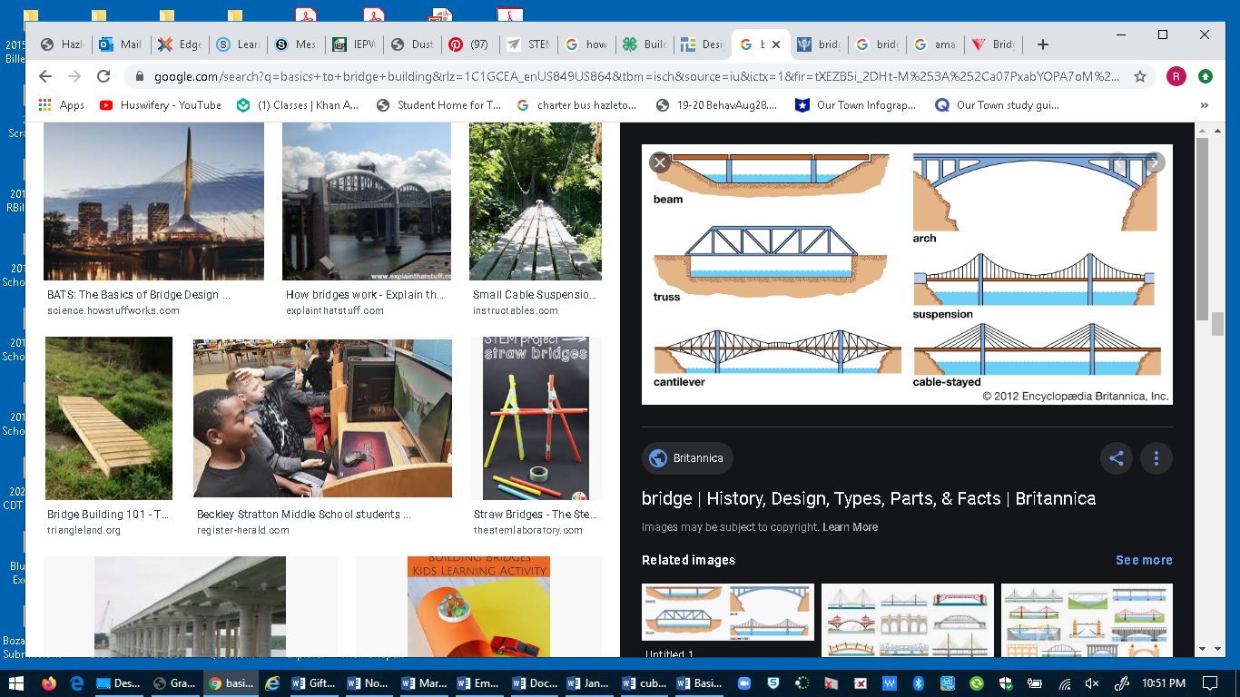
https://www.britannica.com/technology/bridge-engineering
=============
http://www.pbs.org/wgbh/buildingbig/bridge/basics.html
There are more than half a million bridges in the United States, and you rely on them every day to cross obstacles like streams, valleys, and railroad tracks. But do you know how they work? Or why some bridges are curved while others are straight? Engineers must consider many things -- like the distance to be spanned and the types of materials available -- before determining the size, shape, and overall look of a bridge.
Since ancient times, engineers have designed three major types of bridges to withstand all forces of nature.
The beam bridge...
consists of a horizontal beam supported at each end by piers. The weight of the beam pushes straight down on the piers. The farther apart its piers, the weaker the beam becomes. This is why beam bridges rarely span more than 250 feet.
Sneak a peek at the forces that act on beam bridges!
Check out other types of beam bridges!
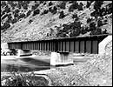
Beam bridge

The truss bridge...
consists of an assembly of triangles. Truss bridges are commonly made from a series of straight, steel bars. The Firth of Forth Bridge in Scotland is a cantilever bridge, a complex version of the truss bridge. Rigid arms extend from both sides of two piers. Diagonal steel tubes, projecting from the top and bottom of each pier, hold the arms in place. The arms that project toward the middle are only supported on one side, like really strong diving boards. These "diving boards," called cantilever arms, support a third, central span.
Check out the forces that act on truss bridges!
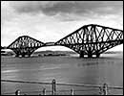
Cantilever bridge:
Firth of Forth

The arch bridge...
has great natural strength. Thousands of years ago, Romans built arches out of stone. Today, most arch bridges are made of steel or concrete, and they can span up to 800 feet.
Catch a glimpse of the forces that act on arch bridges!
Check out how arch bridges are built!
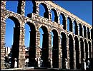
Ancient Roman aqueduct

The suspension bridge...
can span 2,000 to 7,000 feet -- way farther than any other type of bridge! Most suspension bridges have a truss system beneath the roadway to resist bending and twisting.
See how forces act on suspension bridges!
Check out another type of suspension bridge!
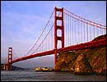
Suspension bridge:
Golden Gate Bridge
Now that you've mastered the bridge basics, test your bridge-building skills in the Bridge Challenge!

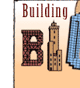 | 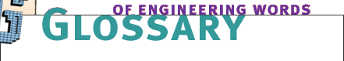

 |  |  | Abutment -  the outermost end supports on a bridge, which carry the load from the deck  Aluminum -  a lightweight chemical element (Al); the most abundant metallic element in the Earth's crust  Anchorage -  a secure fixing, usually made of reinforced concrete to which the cables are fastened  Aqueduct -  a bridge or channel for conveying water, usually over long distances  Arch Bridge -  a curved structure that converts the downward force of its own weight, and of any weight pressing down on top of it, into an outward force along its sides and base  Arch Dam -  a dam with an arched shape that resists the force of water pressure; requires less material than a gravity dam for the same distance  Architect -  a person who designs all kinds of structures; must also have the ability to conceptualize and communicate ideas effectively -- both in words and on paper -- to clients, engineers, government officials, and construction crews  Beam -  a rigid, usually horizontal, structural element  Beam Bridge -  a simple type of bridge, composed of horizontal beams supported by vertical posts  Bedrock -  the solid rock layer beneath sand or silt  Bend -  (v.) to curve; bending occurs when a straight material becomes curved; one side squeezes together in compression, and the other side stretches apart in tension  Bends -  (n.) see caisson disease  Brace -  (n.) a structural support; (v.) to strengthen and stiffen a structure to resist loads  Brittle -  characteristic of a material that fails without warning; brittle materials do not stretch or shorten before failing  Buckle -  to bend under compression  Buttress -  a support that transmits a force from a roof or wall to another supporting structure  Buttress Dam -  a gravity dam reinforced by structural supports  Cable -  a structural element formed from steel wire bound in strands; the suspending element in a bridge; the supporting element in some dome roofs  Cable-Stayed Bridge -  a bridge in which the roadway deck is suspended from cables anchored to one or more towers  Caisson -  a watertight, dry chamber in which people can work underwater  Caisson Disease -  an affliction developed by people moving in and out of caissons quickly; also called the bends and decompression sickness  Cantilever -  a projecting structure supported only at one end, like a shelf bracket or a diving board  Cast Iron -  a brittle alloy with high carbon content; iron that has been melted, then poured into a form and cooled; can be made into any shape desired  Civil Engineer -  an engineer who plans, designs, and supervises the construction of facilities essential to modern life  Cement -  a binding material, or glue, that helps concrete harden  Coffer -  a sunken panel in a ceiling  Cofferdam -  a temporary dam built to divert a river around a construction site so the dam can be built on dry ground  Column -  a vertical, structural element, strong in compression  Compressed-Air Chamber -  the space at the bottom of a caisson into which air is introduced under pressure to exclude water so that excavation can take place  Compression -  a pressing force that squeezes a material together  Concrete -  a mixture of water, sand, small stones, and a gray powder called cement  Construction Manager -  a person who coordinates the entire construction process -- from initial planning and foundation work through the structure's completion  Continuous Span Beam Bridge -  simple bridge made by linking one beam bridge to another; some of the longest bridges in the world are continuous span beam bridges  Core -  central region of a skyscraper; usually houses elevator and stairwell  Cut and Cover -  a method of tunnel construction that involves digging a trench, building a tunnel, and then covering it with fill  Deck -  supported roadway on a bridge  Deform -  to change shape  Diversion Channel -  a bypass created to divert water around a dam so that construction can take place  Dome -  a curved roof enclosing a circular space; a three-dimensional arch  Downstream Face -  the side of the dam that is not against the water  Dynamite -  a blasting explosive, based on nitroglycerin, but much safer to handle than nitroglycerin alone  Electrical Engineer -  an engineer concerned with electrical devices and systems and with the use of electrical energy  Embankment Dam -  a dam composed of a mound of earth and rock; the simplest type of gravity dam  Engineering -  a profession in which a knowledge of math and natural science is applied to develop ways to utilize the materials and forces of nature for the benefit of all human beings  Environmental Engineer -  an engineer who designs and operates systems to provide safe drinking water and to prevent and control pollution in water, in the air, and on the land  Fire-Setting -  an ancient tunneling technique in which rock is heated with fire and then doused with cold water, causing the rock to fracture  Force -  any action that tends to maintain or alter the position of a structure  Geodesic Dome -  a dome composed of short, straight pieces joined to form triangles; invented by Buckminster Fuller  Geotechnical Engineer -  an engineer who evaluates and stabilizes foundations for buildings, roads, and other structures  Gravity Dam -  a dam constructed so that its great weight resists the force of water pressure  Gunpowder -  any of several low-explosive mixtures used as a blasting agent in mining and tunneling; the first such explosive was black powder, which consists of a mixture of potassium nitrate, sulfur, and charcoal  Iron -  a chemical element (Fe); one of the cheapest and most used metals  Joint -  a device connecting two or more adjacent parts of a structure; a roller joint allows adjacent parts to move controllably past one another; a rigid joint prevents adjacent parts from moving or rotating past one another  Load -  weight distribution throughout a structure; loads caused by wind, earthquakes, and gravity, for example, affect how weight is distributed throughout a structure  Masonry -  a building material such as stone, clay, brick, or concrete  Mechanical Engineer -  an engineer who applies the principles of mechanics and energy to the design of machines and devices  Monolithic Dome -  a dome composed of a series of arches, joined together with a series of horizontal rings called parallels  Movable Bridge -  a bridge in which the deck moves to clear a navigation channel; a swing bridge has a deck that rotates around a center point; a drawbridge has a deck that can be raised and lowered; a bascule bridge deck is raised with counterweights like a drawbridge; and the deck of a lift bridge is raised vertically like a massive elevator  Nitroglycerin -  an explosive compound made from a mixture of glycerol and concentrated nitric and sulfuric acids, and an important ingredient of most forms of dynamite  Perimeter -  the distance around the outside of a shape  Pier -  a vertical supporting structure, such as a pillar  Pendentive -  a triangular shape that adapts the circular ring of a dome to fit onto a flat supporting wall  Pile -  a long, round pole of wood, concrete, or steel driven into the soil by pile drivers  Pile Driver -  a noisy machine that repeatedly drops a heavy weight on top of a pile until the pile reaches solid soil or rock or cannot be pushed down any farther  Plastic -  a synthetic material made from long chains of molecules; has the capability of being molded or shaped, usually by the application of heat and pressure  Pressure -  a force applied or distributed over an area  Reinforced Concrete -  concrete with steel bars or mesh embedded in it for increased strength in tension; in pre-tensioned concrete, the embedded steel bars or cables are stretched into tension before the concrete hardens; in post-tensioned concrete, the embedded steel bars or cables are stretched into tension after the concrete hardens  Richter Scale -  used to measure the magnitude of an earthquake; introduced in 1935 by the seismologists Beno Gutenberg and Charles Francis Richter  Rigid -  (adj.) ability to resist deformation when subjected to a load; rigidity (n.) the measure of a structure's ability not to change shape when subjected to a load  Rock Tunnel -  a passage constructed through solid rock  Shear -  a force that causes parts of a material to slide past one another in opposite directions  Shear-Walls -  solid concrete walls that resist shear forces; often used in buildings constructed in earthquake zones  Silt -  sediment particles ranging from 0.004 to 0.06 mm (0.00016 to 0.0024 inch) in diameter  Soft-Ground Tunnels -  a passage constructed through loose, unstable, or wet ground, requiring supports to keep the walls from collapsing  Span -  (n.) the distance a bridge extends between two supports; (v.) to traverse a specific distance  Spillway -  an overflow channel that allows dam operators to release lake water when it gets high enough to threaten the safety of a dam  Spire -  an architectural or decorative feature of a skyscraper; the Council on Tall Buildings and Urban Habitat includes spires but not antennae when calculating the official height of a skyscraper  Stable -  (adj.) ability to resist collapse and deformation; stability (n.) characteristic of a structure that is able to carry a realistic load without collapsing or deforming significantly  Steel -  an alloy of iron and carbon that is hard, strong, and malleable  Stiff -  (adj.) ability to resist deformation; stiffness (n.) the measure of a structure's capacity to resist deformation  Story -  floor of a skyscraper  Strong -  (adj.) ability to carry a realistic load; strength (n.) the measure of a structure's ability to carry a realistic load  Structural Engineer -  an engineer who investigates the behavior and design of all kinds of structures, including dams, domes, tunnels, bridges, and skyscrapers, to make sure they are safe and sound for human use  Suspension Bridge -  a bridge in which the roadway deck is suspended from cables that pass over two towers; the cables are anchored in housings at either end of the bridge  Tailings Dam -  a dam, usually made of earth and rock, used to contain mining waste  Tensegrity -  an array of tension cables and compression rods that supports a structure; invented by Buckminster Fuller student Kenneth Snellson  Tension -  a stretching force that pulls on a material  Tension Ring -  a support ring that resists the outward force pushing against the lower sides of a dome  Torsion -  an action that twists a material  Tower -  the vertical structure in a suspension bridge or cable-stayed bridge from which cables are hung; also used loosely as a synonym for the term skyscraper  Truss -  a rigid frame composed of short, straight pieces joined to form a series of triangles or other stable shapes  Tuned Mass Damper -  a mechanical counterweight designed to reduce the effects of motion, such as the swaying of a skyscraper in the wind or in an earthquake  Tunnel Boring Machine (TBM) -  a mechanical device that tunnels through the ground  Tunnel Shield -  a cylinder pushed ahead of tunneling equipment to provide advance support for the tunnel roof; used when tunneling in soft or unstable ground  Unstable -  characteristic of a structure that collapses or deforms under a realistic load  Upstream Face -  the side of a dam that is against the water  Wood -  a common natural material strong in both compression and tension  Wrought Iron -  an iron alloy that is less brittle than cast iron
  A | B | C | D | E | F | G | H | I | J | K | L | M
  N | O| P | Q | R| S | T | U | V | W | X | Y | Z

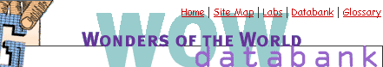

Bridge | Dam | Dome | Other | Skyscraper | Tunnel
Bridge
Akashi Kaikyo Bridge
Brooklyn Bridge
Charles River Bridge
Chesapeake Bay Bridge-Tunnel
Firth of Forth Bridge
Garabit Viaduct
George P. Coleman Bridge
Golden Gate Bridge
Iron Bridge
New River Gorge Bridge
Sunshine Skyway Bridge
Tacoma Narrows Bridge
Tower Bridge
Dam
Aswan High Dam
Edwards Dam
Folsom Dam
Grand Coulee Dam
Hoover Dam
Itaipu Dam
South Fork Dam
Three Gorges Dam
Dome
Astrodome
Climatron
Georgia Dome
Hagia Sophia
Mihrimah Mosque
Olympic Stadium
Pantheon
SkyDome
St. Peter's Basilica
United States Capitol
Skyscraper
Chrysler Building
Citicorp Center
Eiffel Tower
Empire State Building
First Interstate World Center (Library Tower)
Home Insurance Building
John Hancock Center
Petronas Towers
Sears Tower
World Trade Center
Tunnel
Central Artery/Tunnel Project (Big Dig)
Channel Tunnel (Chunnel)
Chesapeake Bay Bridge-Tunnel
Holland Tunnel
Hoosac Tunnel
London Underground
New York Third Water Tunnel
Paw Paw Tunnel
Seikan Tunnel
Thames Tunnel
Underground Canal
Other Structures from Who Builds Big
Harris County New Exposition Center
J. Paul Getty Center
New York State Capitol
United States Courthouse, Seattle

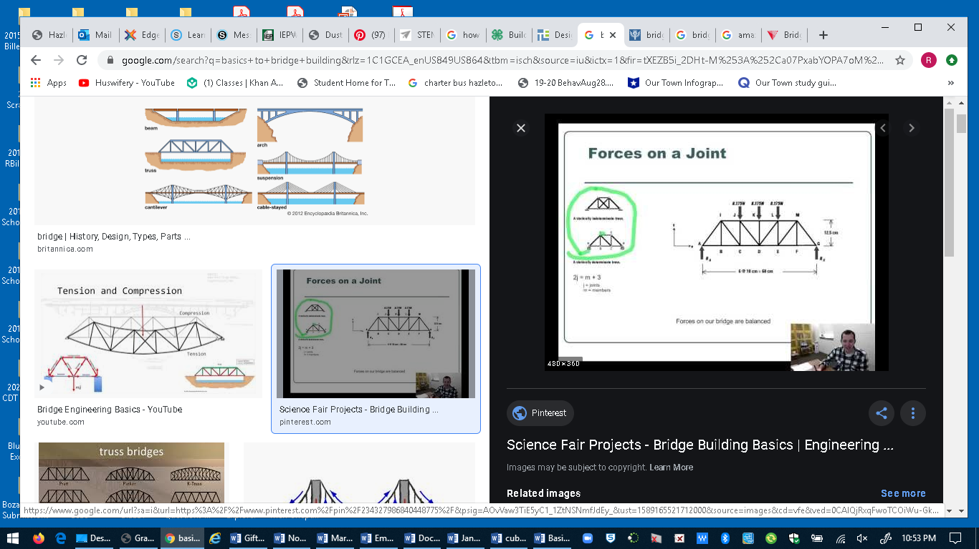

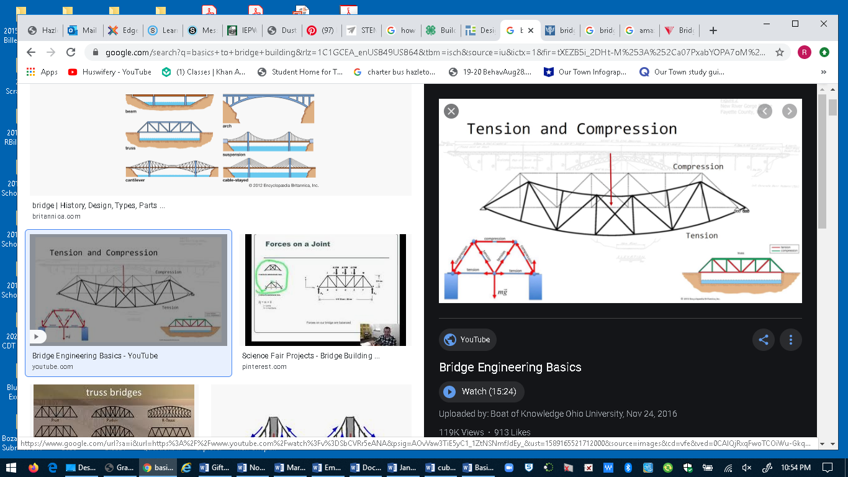

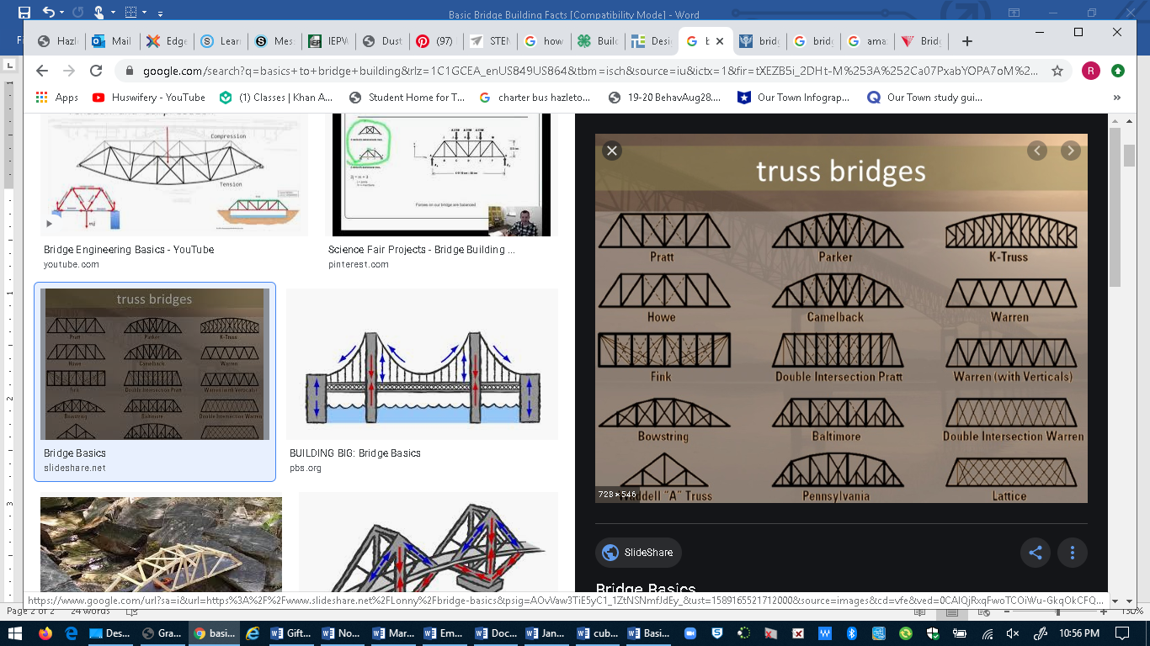

https://www.slideshare.net/Lonny/bridge-basics 21 slides

How to build a Popsicle Bridge
https://www.instructables.com/id/Popsicle-Stick-Bridge/

